在最新的hadoop 2.6.0版本中，YARN引入了一种新的调度策略：基于标签的调度机制。该机制的主要引入动机是更好地让YARN运行在异构集群中，进而更好地管理和调度混合类型的应用程序。

http://doc.mapr.com/display/MapR/Label-based+Scheduling

http://hortonworks.com/blog/support-long-running-services-hadoop-yarn-clusters/?utm_source=tuicool&utm_medium=referral

http://blog.sequenceiq.com/blog/2014/11/10/new-yarn-features-part-1-label-based-scheduling/

https://docs.hortonworks.com/HDPDocuments/HDP2/HDP-2.3.4/bk_yarn_resource_mgt/content/ch_node_labels.html

http://aajisaka.github.io/hadoop-project/hadoop-yarn/hadoop-yarn-site/NodeLabel.html

http://www.cloudera.com/documentation/enterprise/5-4-x/topics/cdh_rn_new_in_547.html?q=labels

# 配置基于hadoop-yarn-label-based-scheduling功能条件是,一个正常使用的集群！
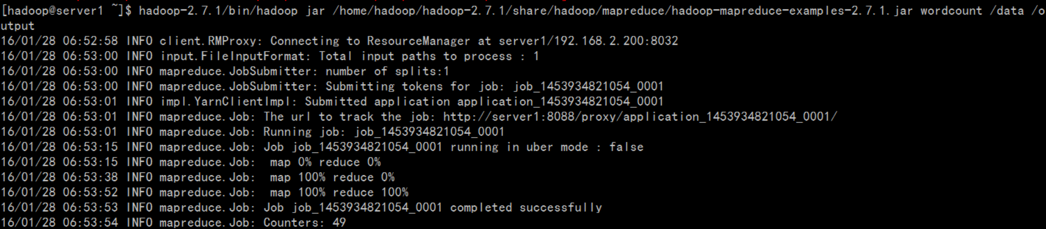

#环境是2个node，hadoop-2.7.1
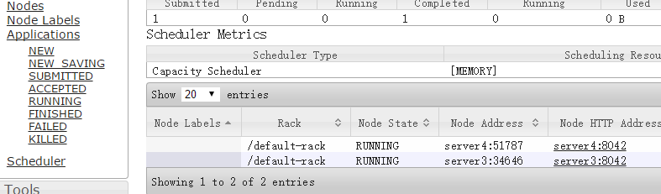

# 调度策略
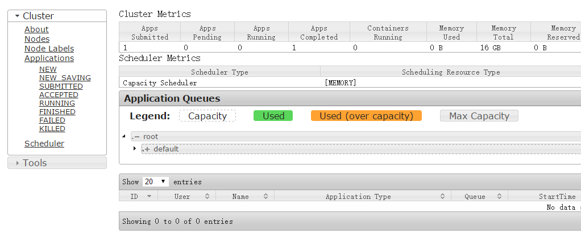

# 开启yarn.node-labels.enabled功能,添加系统级别的label
1、配置Yarn-site.xml，追加内容：
<property>
<name>yarn.node-labels.enabled</name>
<value>true</value>
</property>
<property>
<name>yarn.node-labels.fs-store.root-dir</name>
<value>hdfs://mycluster/yarn/node-labels</value>
</property>
<property>
<name>yarn.nodemanager.address</name>
<value>0.0.0.0:45454</value>
</property>
<property>
<name>yarn.node-labels.manager-class</name>
<value>org.apache.hadoop.yarn.server.resourcemanager.nodelabels.RMNodeLabelsManager</value>
</property>
<property>
<name>yarn.resourcemanager.scheduler.class</name>
<value>org.apache.hadoop.yarn.server.resourcemanager.scheduler.capacity.CapacityScheduler</value>
</property>

## 追加capacity-scheduler.xml
<property>
<name>yarn.scheduler.capacity.root.queues</name>
<value>mapred,llama</value>
</property>

<property>
<name>yarn.scheduler.capacity.root.accessible-node-labels.fastcpu.capacity</name>
<value>100</value>
</property>

<property>
<name>yarn.scheduler.capacity.root.accessible-node-labels.highmem.capacity</name>
<value>100</value>
</property>

<!-- configuration of queue-mapred -->
<property>
<name>yarn.scheduler.capacity.root.mapred.accessible-node-labels</name>
<value>fastcpu,highmem</value>
</property>

<property>
<name>yarn.scheduler.capacity.root.mapred.capacity</name>
<value>40</value>
</property>

<property>
<name>yarn.scheduler.capacity.root.mapred.accessible-node-labels.fastcpu.capacity</name>
<value>100</value>
</property>

<property>
<name>yarn.scheduler.capacity.root.mapred.accessible-node-labels.highmem.capacity</name>
<value>50</value>
</property>

<property>
<name>yarn.scheduler.capacity.root.mapred.queues</name>
<value>a1,a2</value>
</property>

<!-- configuration of queue-llama -->
<property>
<name>yarn.scheduler.capacity.root.llama.accessible-node-labels</name>
<value>highmem</value>
</property>

<property>
<name>yarn.scheduler.capacity.root.llama.capacity</name>
<value>60</value>
</property>

<property>
<name>yarn.scheduler.capacity.root.llama.accessible-node-labels.highmem.capacity</name>
<value>50</value>
</property>

<property>
<name>yarn.scheduler.capacity.root.llama.queues</name>
<value>b1</value>
</property>

<!-- configuration of queue-mapred.a1 -->
<property>
<name>yarn.scheduler.capacity.root.mapred.a1.accessible-node-labels</name>
<value>fastcpu,highmem</value>
</property>

<property>
<name>yarn.scheduler.capacity.root.mapred.a1.capacity</name>
<value>40</value>
</property>

<property>
<name>yarn.scheduler.capacity.root.mapred.a1.accessible-node-labels.fastcpu.capacity</name>
<value>30</value>
</property>

<property>
<name>yarn.scheduler.capacity.root.mapred.a1.accessible-node-labels.highmem.capacity</name>
<value>50</value>
</property>

<!-- configuration of queue-mapred.a2 -->
<property>
<name>yarn.scheduler.capacity.root.mapred.a2.accessible-node-labels</name>
<value>fastcpu,highmem</value>
</property>

<property>
<name>yarn.scheduler.capacity.root.mapred.a2.capacity</name>
<value>60</value>
</property>

<property>
<name>yarn.scheduler.capacity.root.mapred.a2.accessible-node-labels.fastcpu.capacity</name>
<value>70</value>
</property>

<property>
<name>yarn.scheduler.capacity.root.mapred.a2.accessible-node-labels.highmem.capacity</name>
<value>50</value>
</property>

<!-- configuration of queue-llama.b1 -->
<property>
<name>yarn.scheduler.capacity.root.llama.b1.accessible-node-labels</name>
<value>highmem</value>
</property>

<property>
<name>yarn.scheduler.capacity.root.llama.b1.capacity</name>
<value>100</value>
</property>

<property>
<name> yarn.scheduler.capacity.root.llama.b1.default-node-label-expression</name>
<value> highmem</value>
</property>

<property>
<name>yarn.scheduler.capacity.root.llama.b1.accessible-node-labels.highmem.capacity</name>
<value>100</value>
</property>

修改配置之后,重启yarn，页面没有任何变化除了资源池！后台多了一个目录：
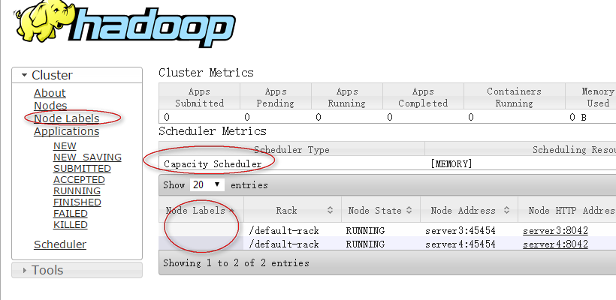
资源池变化：
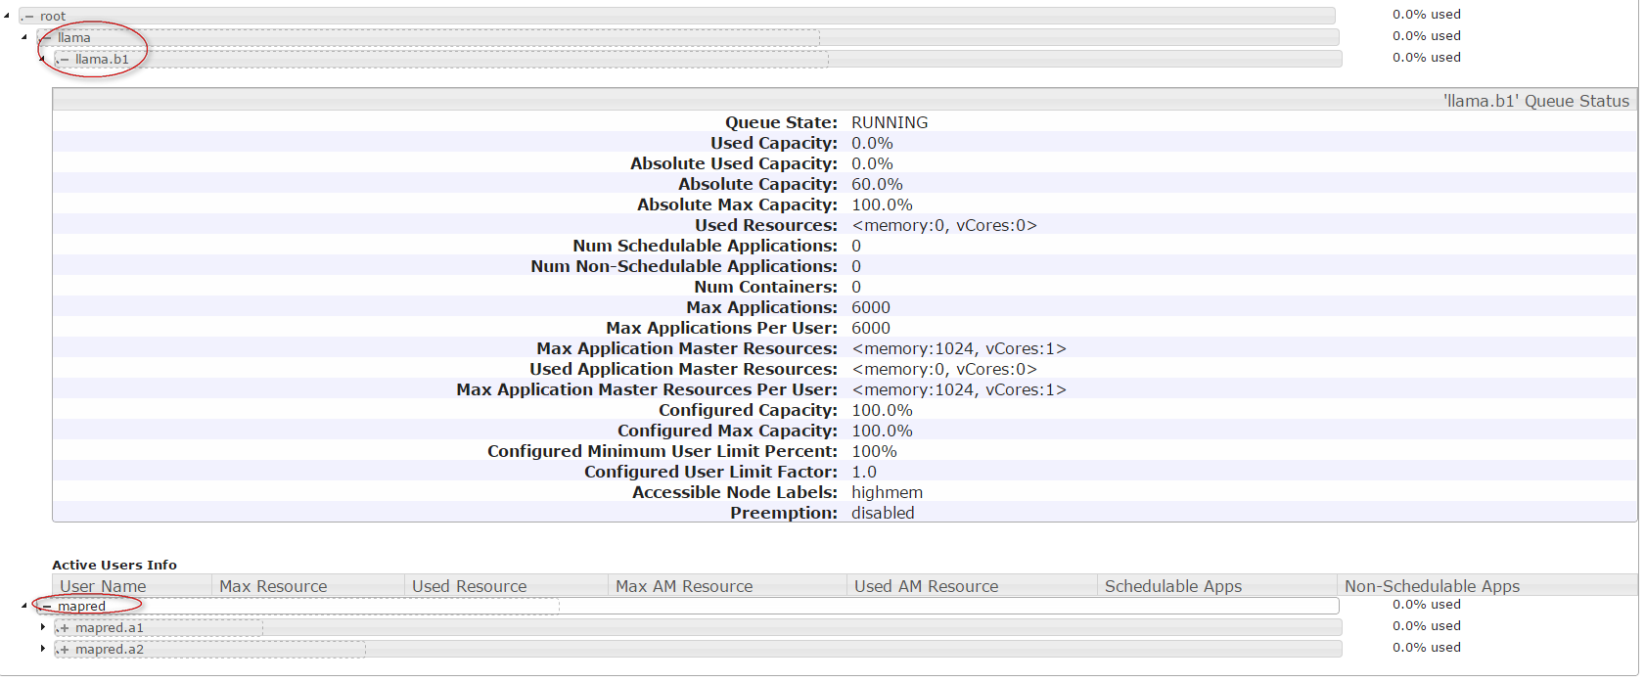

2、添加系统级别lables标签
[hadoop@server1 hadoop]$ /home/hadoop/hadoop-2.7.1/bin/yarn rmadmin -addToClusterNodeLabels fastcpu,highmem
16/01/28 07:15:41 INFO client.RMProxy: Connecting to ResourceManager at server1/192.168.2.200:8033

#页面发生变化
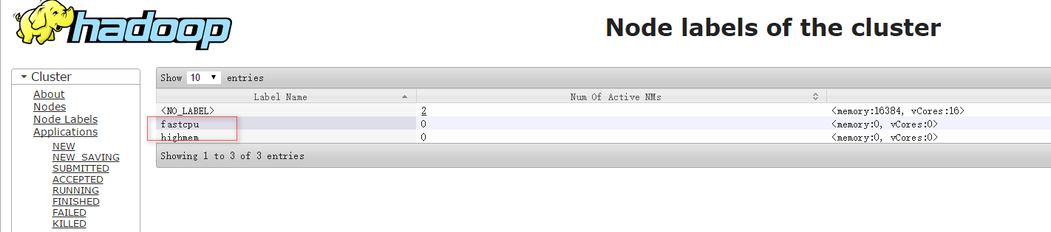

3、给各个节点打标签(可动态修改)
[hadoop@server1 hadoop]$ /home/hadoop/hadoop-2.7.1/bin/yarn rmadmin -replaceLabelsOnNode "server3,fastcpu"
16/01/28 07:18:33 INFO client.RMProxy: Connecting to ResourceManager at server1/192.168.2.200:8033

[hadoop@server1 hadoop]$ /home/hadoop/hadoop-2.7.1/bin/yarn rmadmin -replaceLabelsOnNode "server4,highmem"
16/01/28 07:19:08 INFO client.RMProxy: Connecting to ResourceManager at server1/192.168.2.200:8033

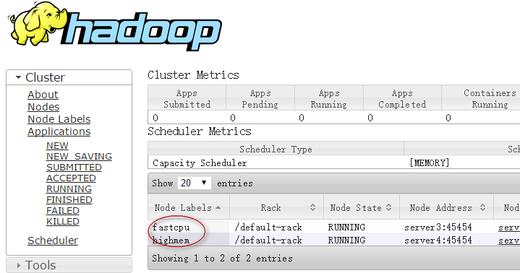
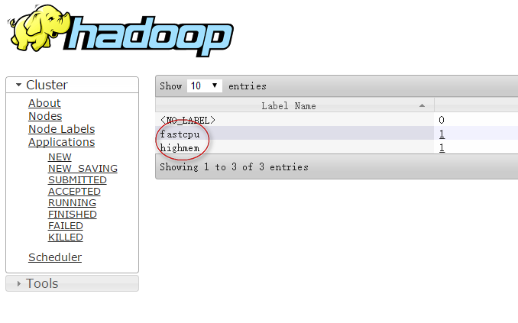

# 查看标签情况, 默认情况下，各个nodemanager的RPC port是随机选取的，你可以将所有的nodemanager配置成一样的，便于管理，上面配置中固定了。
[hadoop@server1 hadoop]$ /home/hadoop/hadoop-2.7.1/bin/yarn cluster --list-node-labels
16/01/28 07:20:58 INFO client.RMProxy: Connecting to ResourceManager at server1/192.168.2.200:8032
Node Labels: fastcpu,highmem

[hadoop@server1 hadoop]$ /home/hadoop/hadoop-2.7.1/bin/yarn node -status server3:45454
16/01/28 07:22:08 INFO client.RMProxy: Connecting to ResourceManager at server1/192.168.2.200:8032
Node Report :
Node-Id : server3:45454
Rack : /default-rack
Node-State : RUNNING
Node-Http-Address : server3:8042
Last-Health-Update : Thu 28/Jan/16 07:20:40:689CST
Health-Report :
Containers : 0
Memory-Used : 0MB
Memory-Capacity : 8192MB
CPU-Used : 0 vcores
CPU-Capacity : 8 vcores
Node-Labels : fastcpu

[hadoop@server1 hadoop]$ /home/hadoop/hadoop-2.7.1/bin/yarn node -list
16/01/28 08:28:28 INFO client.RMProxy: Connecting to ResourceManager at server1/192.168.2.200:8032
Total Nodes:2
Node-Id Node-State Node-Http-Address Number-of-Running-Containers
server3:45454 RUNNING server3:8042 0
server4:45454 RUNNING server4:8042 0

# 查询队列情况
[hadoop@server1 hadoop]$ /home/hadoop/hadoop-2.7.1/bin/hadoop queue -list
DEPRECATED: Use of this script to execute mapred command is deprecated.
Instead use the mapred command for it.

16/01/28 08:49:56 INFO client.RMProxy: Connecting to ResourceManager at server1/192.168.2.200:8032
======================
Queue Name : llama
Queue State : running
Scheduling Info : Capacity: 60.000004, MaximumCapacity: 100.0, CurrentCapacity: 0.0
======================
Queue Name : b1
Queue State : running
Scheduling Info : Capacity: 100.0, MaximumCapacity: 100.0, CurrentCapacity: 0.0
======================
Queue Name : mapred
Queue State : running
Scheduling Info : Capacity: 40.0, MaximumCapacity: 100.0, CurrentCapacity: 0.0
======================
Queue Name : a1
Queue State : running
Scheduling Info : Capacity: 40.0, MaximumCapacity: 100.0, CurrentCapacity: 0.0
======================
Queue Name : a2
Queue State : running
Scheduling Info : Capacity: 60.000004, MaximumCapacity: 100.0, CurrentCapacity: 0.0

[hadoop@server1 hadoop]$ /home/hadoop/hadoop-2.7.1/bin/yarn rmadmin -refreshQueues
16/01/28 08:29:51 INFO client.RMProxy: Connecting to ResourceManager at server1/192.168.2.200:8033

通过Yarn Web的Node Labels也可以查看各个节点的标签。
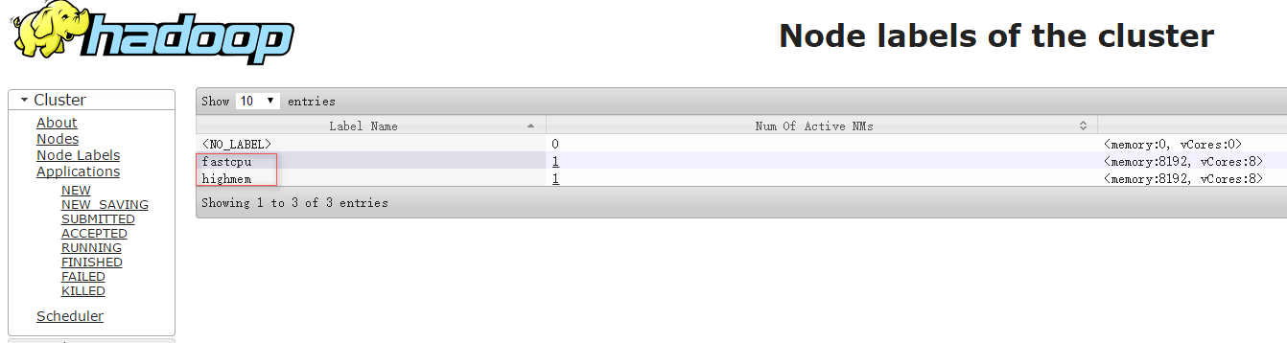
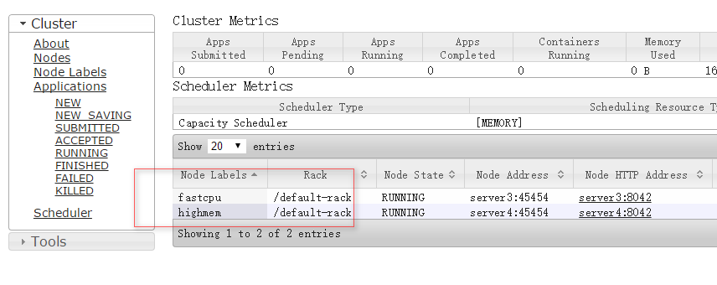

# 提交任务到指定队列
<property>
<name>yarn.scheduler.capacity.root.queues</name>
<value>llama,mapred</value> #配置了这几个队列
</property>
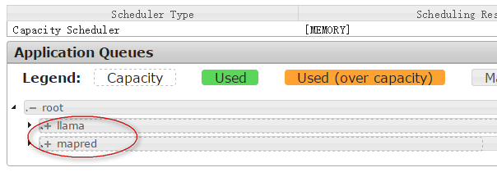

[hadoop@server1 ~]$ hadoop-2.7.1/bin/hadoop jar /home/hadoop/hadoop-2.7.1/share/hadoop/mapreduce/hadoop-mapreduce-examples-2.7.1.jar pi -Dmapreduce.job.queuename=b1 1 10

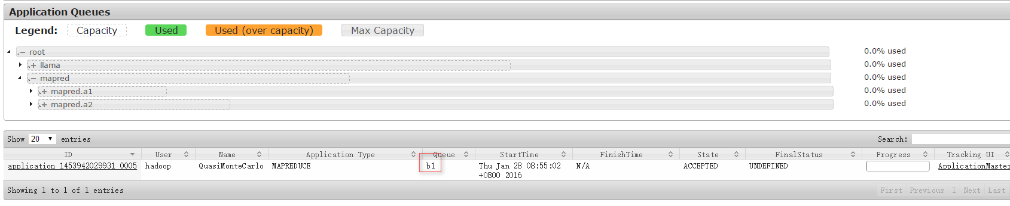

[hadoop@server1 ~]$ hadoop-2.7.1/bin/hadoop jar /home/hadoop/hadoop-2.7.1/share/hadoop/mapreduce/hadoop-mapreduce-examples-2.7.1.jar pi -Dmapreduce.j.queuename=a1 1 10

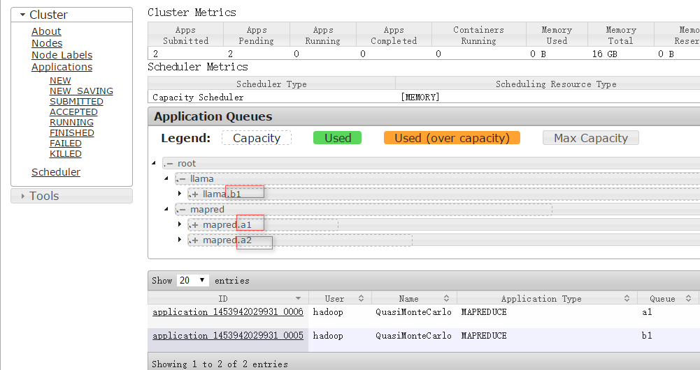

注意：目前还不支持提交应用程序时指定标签,只能通过指定队列，并设置队列的默认标签达到目的。我看到HDP官网有个指定标签的项，感觉(瞅了一眼,不用感觉了是真的)是Mr config对象中指定的，命令行没有提供类似的参数！
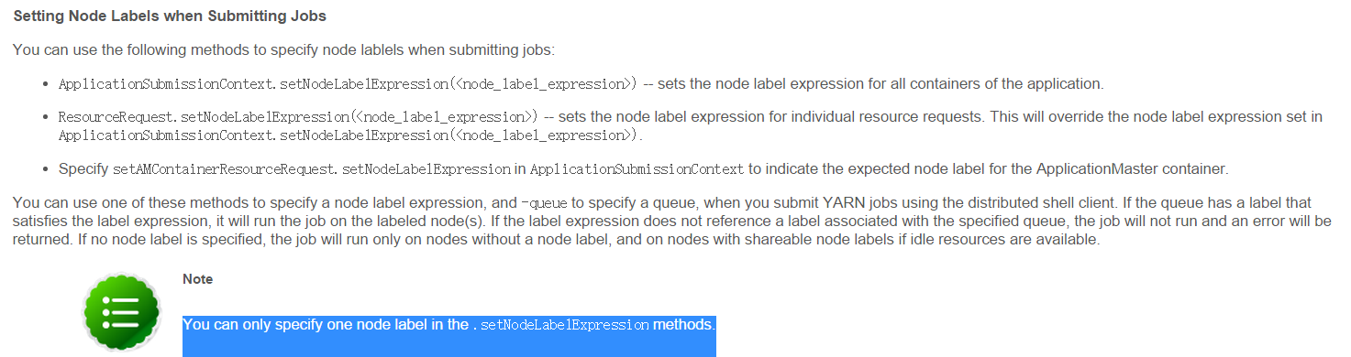
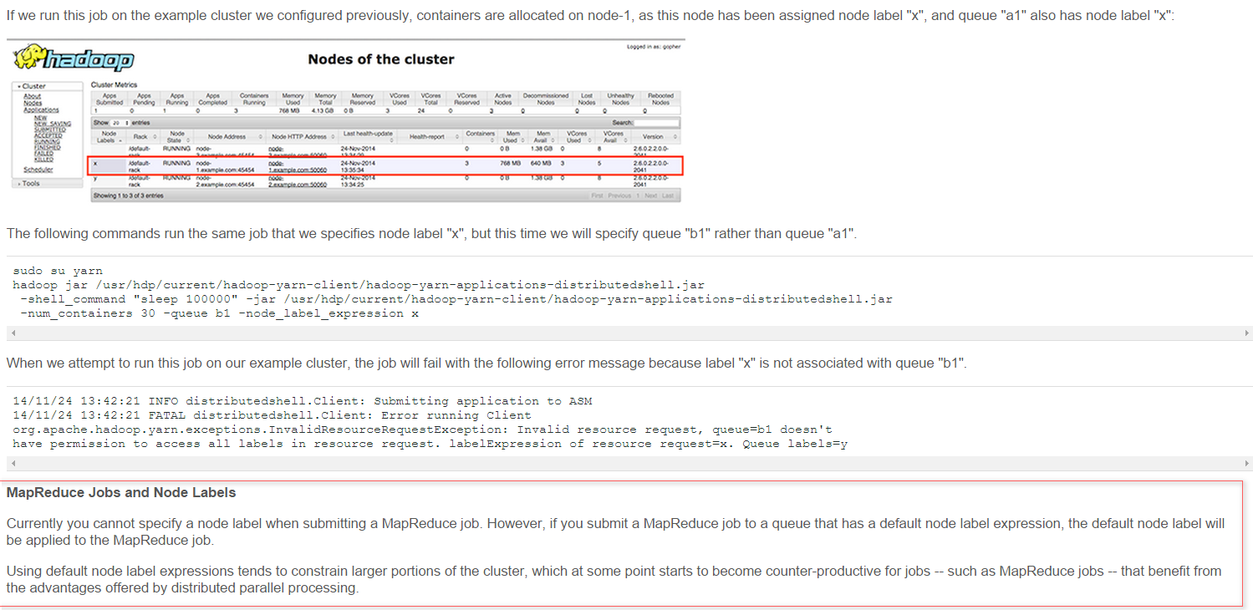
注意最后一段话…

