openvpn服务

准备
[root@node1 tools]# cat /etc/redhat-release
CentOS release 6.8 (Final)
[root@node1 tools]# uname -r
2.6.32-642.11.1.el6.x86_64
[root@node1 tools]# uname -m
x86_64
[root@node1 tools]# lsb_release -a
LSB Version: :base-4.0-amd64:base-4.0-noarch:core-4.0-amd64:core-4.0-noarch:graphics-4.0-amd64:graphics-4.0-noarch:printing-4.0-amd64:printing-4.0-noarch
Distributor ID: CentOS
Description: CentOS release 6.8 (Final)
Release: 6.8
Codename: Final
[root@node1 tools]# uname -a
Linux node1 2.6.32-642.11.1.el6.x86_64 #1 SMP Fri Nov 18 19:25:05 UTC 2016 x86_64 x86_64 x86_64 GNU/Linux
[root@node1 tools]# date
2016年 12月 23日 星期五 01:19:30 CST
[root@node1 tools]# ntpdate pool.ntp.org 手工同步时间
28 Dec 16:46:56 ntpdate[26868]: step time server 223.112.179.133 offset 487515.927926 sec
[root@node1 tools]# date
2016年 12月 28日 星期三 16:47:01 CST
[root@node1 tools]# echo '*/5 * * * * /usr/sbin/ntpdate pool.ntp.org >/dev/null 2>&1' >>/var/spool/cron/root
[root@node1 tools]# crontab -l
*/5 * * * * /usr/sbin/ntpdate pool.ntp.org >/dev/null 2>&1

安装依赖包
cd /tools/
wget http://www.oberhumer.com/opensource/lzo/download/lzo-2.02.tar.gz
tar xf lzo-2.02.tar.gz
cd lzo-2.02
./configure
make
make install

yum -y install openssl-devel
安装OPENVPN
tar xf openvpn-2.0.9.tar.gz
cd openvpn-2.0.9
./configure --with-lzo-headers=/usr/local/include --with-lzo-lib=/usr/local/lib
make
make install

[root@node1 /]# ll /usr/local/sbin/openvpn
-rwxr-xr-x. 1 root root 1873206 12月 28 17:29 /usr/local/sbin/openvpn

建立CA证书
cd /tools/openvpn-2.0.9/easy-rsa/2.0/
vim vars
注销如下内容：
#export KEY_COUNTRY="US"
#export KEY_PROVINCE="CA"
#export KEY_CITY="SanFrancisco"
#export KEY_ORG="Fort-Funston"
#export KEY_EMAIL="me@myhost.mydomain"
新增如下内容：
export KEY_COUNTRY="CN"
export KEY_PROVINCE="BJ"
export KEY_CITY="Beijing"
export KEY_ORG="oldboy"
export KEY_EMAIL="12116063@qq.com"

[root@node1 2.0]# source vars 使脚本生效
[root@node1 2.0]# ./clean-all 清楚其他秘钥
[root@node1 2.0]# ./build-ca 建立CA 证书
Generating a 1024 bit RSA private key
..........++++++
.........................++++++
writing new private key to 'ca.key'
-----
You are about to be asked to enter information that will be incorporated
into your certificate request.
What you are about to enter is what is called a Distinguished Name or a DN.
There are quite a few fields but you can leave some blank
For some fields there will be a default value,
If you enter '.', the field will be left blank.
-----
Country Name (2 letter code) [CN]:（直接回车）
State or Province Name (full name) [BJ]:（直接回车）
Locality Name (eg, city) [Beijing]:（直接回车）
Organization Name (eg, company) [oldboy]:（直接回车）
Organizational Unit Name (eg, section) []:
Common Name (eg, your name or your server's hostname) [oldboy CA]:应输入VPN服务器的FQDN
Email Address [12116063@qq.com]: （直接回车）
[root@node1 2.0]# ll keys/
总用量 12
-rw-r--r--. 1 root root 1176 12月 28 18:50 ca.crt
-rw-------. 1 root root 916 12月 28 18:50 ca.key
-rw-r--r--. 1 root root 0 12月 28 18:50 index.txt
-rw-r--r--. 1 root root 3 12月 28 18:50 serial

服务端证书
[root@node1 2.0]# ./build-key-server server
Generating a 1024 bit RSA private key
.++++++
...........................................................................++++++
writing new private key to 'server.key'
-----
You are about to be asked to enter information that will be incorporated
into your certificate request.
What you are about to enter is what is called a Distinguished Name or a DN.
There are quite a few fields but you can leave some blank
For some fields there will be a default value,
If you enter '.', the field will be left blank.
-----
Country Name (2 letter code) [CN]:
State or Province Name (full name) [BJ]:
Locality Name (eg, city) [Beijing]:
Organization Name (eg, company) [oldboy]:
Organizational Unit Name (eg, section) []:
Common Name (eg, your name or your server's hostname) [server]:server
Email Address [12116063@qq.com]:

Please enter the following 'extra' attributes
to be sent with your certificate request
A challenge password []:oldboy
An optional company name []:
Using configuration from /tools/openvpn-2.0.9/easy-rsa/2.0/openssl.cnf
Check that the request matches the signature
Signature ok
The Subject's Distinguished Name is as follows
countryName :PRINTABLE:'CN'
stateOrProvinceName :PRINTABLE:'BJ'
localityName :PRINTABLE:'Beijing'
organizationName :PRINTABLE:'oldboy'
commonName :PRINTABLE:'server'
emailAddress :IA5STRING:'12116063@qq.com'
Certificate is to be certified until Dec 26 11:32:00 2026 GMT (3650 days)
Sign the certificate? [y/n]:y

1 out of 1 certificate requests certified, commit? [y/n]y
Write out database with 1 new entries
Data Base Updated
[root@node1 2.0]# ll -lrt keys/server.*
-rw-------. 1 root root 916 12月 28 19:32 keys/server.key
-rw-r--r--. 1 root root 692 12月 28 19:32 keys/server.csr
-rw-r--r--. 1 root root 3799 12月 28 19:32 keys/server.crt

客户端证书
[root@node1 2.0]# ./build-key oldboy
Generating a 1024 bit RSA private key
.++++++
...................++++++
writing new private key to 'oldboy.key'
-----
You are about to be asked to enter information that will be incorporated
into your certificate request.
What you are about to enter is what is called a Distinguished Name or a DN.
There are quite a few fields but you can leave some blank
For some fields there will be a default value,
If you enter '.', the field will be left blank.
-----
Country Name (2 letter code) [CN]:
State or Province Name (full name) [BJ]:
Locality Name (eg, city) [Beijing]:
Organization Name (eg, company) [oldboy]:
Organizational Unit Name (eg, section) []:
Common Name (eg, your name or your server's hostname) [oldboy]:
Email Address [12116063@qq.com]:

Please enter the following 'extra' attributes
to be sent with your certificate request
A challenge password []:oldboy
An optional company name []:
Using configuration from /tools/openvpn-2.0.9/easy-rsa/2.0/openssl.cnf
Check that the request matches the signature
Signature ok
The Subject's Distinguished Name is as follows
countryName :PRINTABLE:'CN'
stateOrProvinceName :PRINTABLE:'BJ'
localityName :PRINTABLE:'Beijing'
organizationName :PRINTABLE:'oldboy'
commonName :PRINTABLE:'oldboy'
emailAddress :IA5STRING:'12116063@qq.com'
Certificate is to be certified until Dec 26 11:39:46 2026 GMT (3650 days)
Sign the certificate? [y/n]:y

1 out of 1 certificate requests certified, commit? [y/n]y
Write out database with 1 new entries
Data Base Updated
[root@node1 2.0]# ll -lrt keys/oldboy.*
-rw-------. 1 root root 916 12月 28 19:39 keys/oldboy.key
-rw-r--r--. 1 root root 692 12月 28 19:39 keys/oldboy.csr
-rw-r--r--. 1 root root 3677 12月 28 19:39 keys/oldboy.crt [root@node1 2.0]#

[root@node1 2.0]# ./build-key-pass qijian
Generating a 1024 bit RSA private key
...........++++++
.........................................................++++++
writing new private key to 'qijian.key'
Enter PEM pass phrase:
Verifying - Enter PEM pass phrase:
-----
You are about to be asked to enter information that will be incorporated
into your certificate request.
What you are about to enter is what is called a Distinguished Name or a DN.
There are quite a few fields but you can leave some blank
For some fields there will be a default value,
If you enter '.', the field will be left blank.
-----
Country Name (2 letter code) [CN]:
State or Province Name (full name) [BJ]:
Locality Name (eg, city) [Beijing]:
Organization Name (eg, company) [oldboy]:
Organizational Unit Name (eg, section) []:
Common Name (eg, your name or your server's hostname) [qijian]:
Email Address [12116063@qq.com]:

Please enter the following 'extra' attributes
to be sent with your certificate request
A challenge password []:oldboy
An optional company name []:
Using configuration from /tools/openvpn-2.0.9/easy-rsa/2.0/openssl.cnf
Check that the request matches the signature
Signature ok
The Subject's Distinguished Name is as follows
countryName :PRINTABLE:'CN'
stateOrProvinceName :PRINTABLE:'BJ'
localityName :PRINTABLE:'Beijing'
organizationName :PRINTABLE:'oldboy'
commonName :PRINTABLE:'qijian'
emailAddress :IA5STRING:'12116063@qq.com'
Certificate is to be certified until Dec 26 11:49:55 2026 GMT (3650 days)
Sign the certificate? [y/n]:y

1 out of 1 certificate requests certified, commit? [y/n]y
Write out database with 1 new entries
Data Base Updated
[root@node1 2.0]# ll -lrt keys/qijian.*
-rw-------. 1 root root 1041 12月 28 19:49 keys/qijian.key
-rw-r--r--. 1 root root 692 12月 28 19:49 keys/qijian.csr
-rw-r--r--. 1 root root 3677 12月 28 19:49 keys/qijian.crt

[root@node1 2.0]# ./build-dh 生成传输秘钥交换协议
Generating DH parameters, 1024 bit long safe prime, generator 2
This is going to take a long time
...................................................................................+........+..+.........................................+............+....................................................................................................................+.+....................................................+..................................................................+..+........................................................................................................................................+........+...+.+...............................................................................+......................+.+.....................................+........................................++*++*++*
-rw-r--r--. 1 root root 245 12月 28 19:53 dh1024.pem

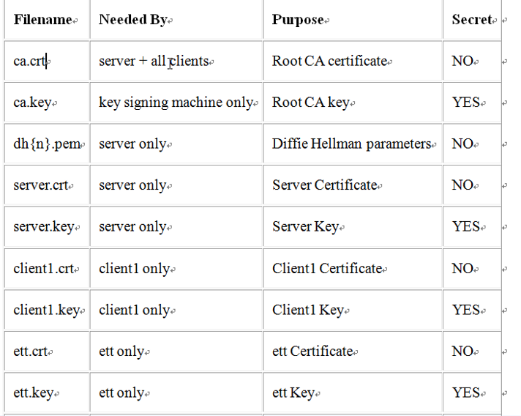
配置文件
mkdir -p /etc/openvpn
cd /tools/openvpn-2.0.9/easy-rsa/2.0
cp -a keys /etc/openvpn/
cd /tools/openvpn-2.0.9/sample-config-files/
cp *.conf /etc/openvpn
tree /etc/openvpn/
cd /etc/openvpn/
[root@node1 openvpn]# egrep -v "^#|^$|^;" server.conf
port 1194
proto udp
dev tun
ca ca.crt
cert server.crt
dh dh1024.pem
server 10.8.0.0 255.255.255.0
ifconfig-pool-persist ipp.txt
keepalive 10 120
comp-lzo
persist-key
persist-tun
status openvpn-status.log
verb 3

egrep -v "^#|^$|^;" server.conf >oldboy-vpn.conf
vim oldboy-vpn.conf
local 10.0.0.5
port 52115
proto tcp
dev tun
ca /etc/openvpn/keys/ca.crt
cert /etc/openvpn/keys/server.crt
key /etc/openvpn/keys/server.key
dh /etc/openvpn/keys/dh1024.pem
server 10.8.0.0 255.255.255.0
ifconfig-pool-persist ipp.txt
keepalive 10 120
comp-lzo
persist-key
persist-tun
status openvpn-status.log
verb 3
push "route 192.168.1.0 255.255.255.0"
client-to-client
log /var/log/openvpn.log
启动VPN
开启防火墙端口拦截
iptables -F
service iptables save
开启转发
vim /etc/sysctl.conf
net.ipv4.ip_forward=1
[root@node1 openvpn]# sysctl -p
启动VPN
/usr/local/sbin/openvpn --config /etc/openvpn/oldboy-vpn.conf &
终止进程
pkill openvpn
查看端口及状态
ps -ef |grep vpn
netstat -lntp

配置开机自启动
vim /etc/rc.local

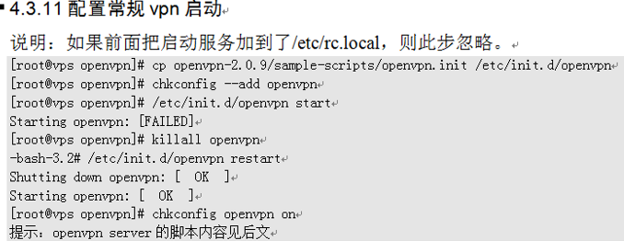

cd /tools/openvpn-2.0.9/sample-scripts/
cp openvpn.init /etc/init.d/openvpn
chkconfig --add openvpn
chkconfig openvpn on
chkconfig --list openvpn
注：如果使用此方法控制启动服务，默认的配置文件是/etc/openvpn/server.conf

下载安装客户端
http://swupdate.openvpn.org/community/releases/openvpn-2.2.2-install.exe
默认安装

客户端配置文件
cd /etc/openvpn/
cp client.conf client.conf.20161229

[root@node1 openvpn]# egrep -v "^#|^$|^;" client.conf
client
dev tun
proto udp
remote my-server-1 1194
resolv-retry infinite
nobind
persist-key
persist-tun
ca ca.crt
cert client.crt
key client.key
comp-lzo
verb 3

[root@node1 openvpn]# egrep -v "^#|^$|^;" client.conf >c-oldboy.conf
vim c-oldboy.conf
client
dev tun
proto tcp
remote 192.168.65.144 52115
resolv-retry infinite
nobind
persist-key
persist-tun
ca ca.crt
cert oldboy.crt
key oldboy.key
comp-lzo
verb 3

将下列文件下载到C:\Program Files (x86)\OpenVPN\config\c-oldboy
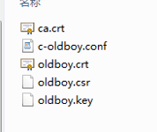
将c-oldboy.conf扩展名修改为ovpn
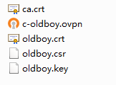

客户端连接OPENVPN服务器
获得IP地址：10.8.0.x
测试网络连通性：ping 10.8.0.1
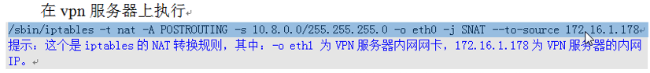

iptables -t nat -I POSTROUTING -s 10.8.0.0/24 -j MASQUERADE
iptables -t nat -A POSTROUTING -s 10.8.0.0/24 -o eth0 -j MASQUERADE
service iptables save
service iptables restart
重要参考资料
https://yq.aliyun.com/articles/43249

openvpn负载均衡高可用方案
方案一：客户端加载两个配置文件
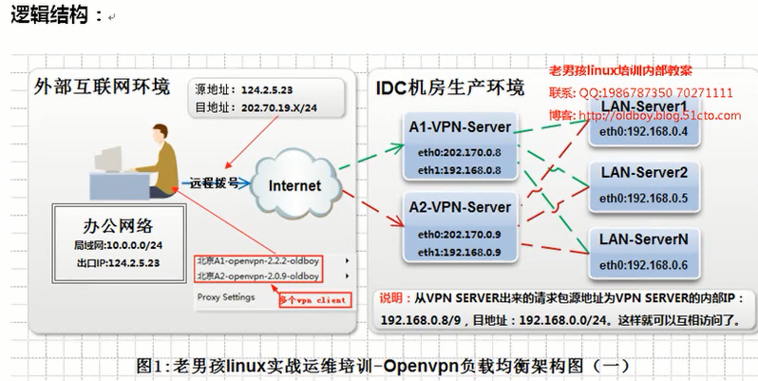

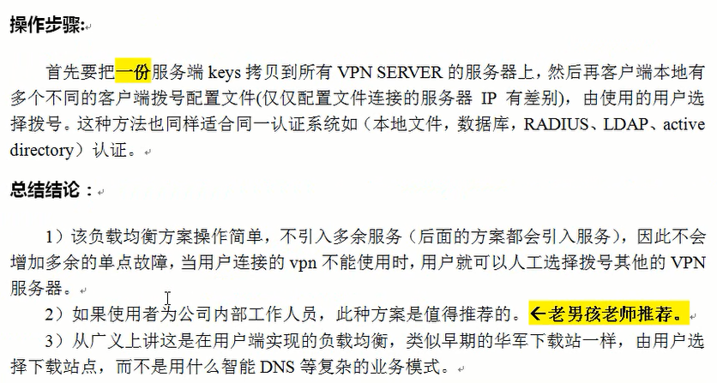

采用用户名密码验证
修改客户端配置文件
在最后添加
auth-user-pass
注销：
cert oldboy.crt
key oldboy.key
修改服务端配置文件
local 192.168.65.144
port 52115
proto tcp
dev tun
ca /etc/openvpn/keys/ca.crt
cert /etc/openvpn/keys/server.crt
key /etc/openvpn/keys/server.key
dh /etc/openvpn/keys/dh1024.pem
server 10.8.0.0 255.255.255.0
ifconfig-pool-persist ipp.txt
keepalive 10 120
comp-lzo
persist-key
persist-tun
status openvpn-status.log
verb 3
push "192.168.1.0 255.255.255.0"
client-to-client
log /var/log/openvpn.log
auth-user-pass-verify /etc/openvpn/checkpsw.sh via-env
client-cert-not-required
username-as-common-name
参数说明：
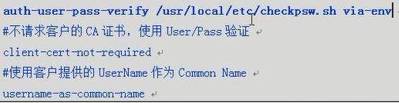

下载checkpsw.sh
[root@node1 openvpn]# vim checkpsw.sh
[root@node1 openvpn]# chmod +x checkpsw.sh

创建授权文件
vim /etc/openvpn/psw-file
oldboy 111111
chmod 400 /etc/openvpn/psw-file
chown root.root /etc/openvpn/psw-file

重启VPN服务
[root@node1 openvpn]# pkill openvpn
[root@node1 openvpn]# ps -ef |grep openvpn
root 60817 58917 0 16:21 pts/2 00:00:00 grep openvpn
[root@node1 openvpn]# /usr/local/sbin/openvpn --config /etc/openvpn/oldboy-vpn.conf &

